SAMBA
- Mount CD1 and install following three packages:
  - Samba-common //(to share on cross platform)
  - Samba //(main samba config file)
  - Samba-client //(for samba client)
- Create a new user (for eg. Here its samba1), provide the user password and also samba password to the user as follows:
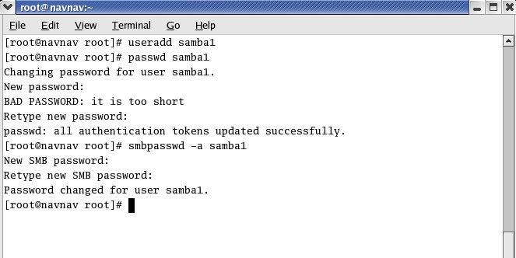
- You can check the encrypted form of samba password using the following command:
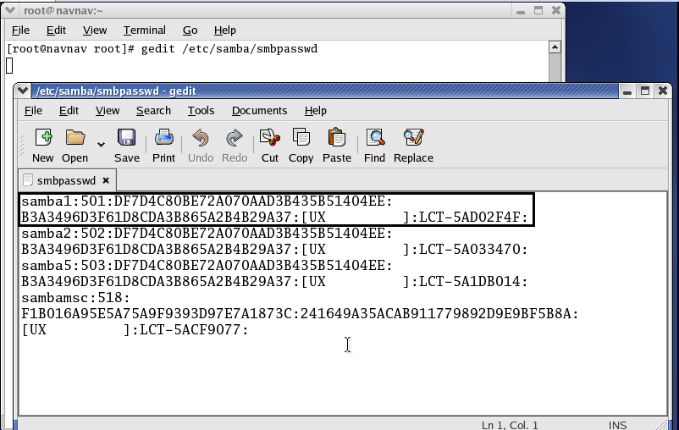
- Now create a directory, file and add content to that file as follows:
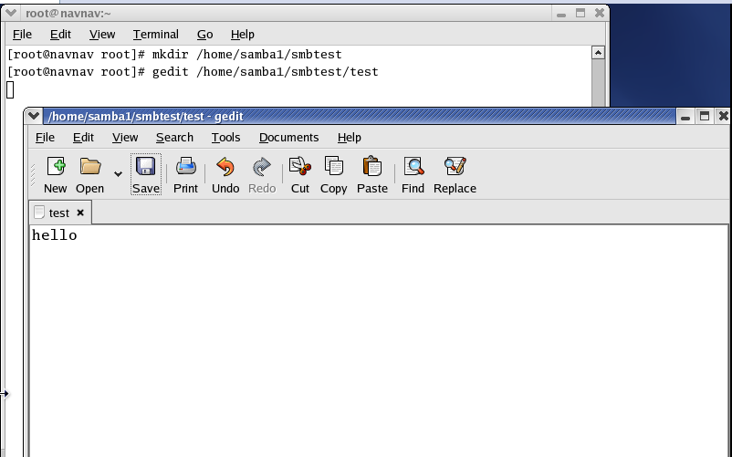
- Make the changes in samba configuration file which are highlighted in the following screenshots:
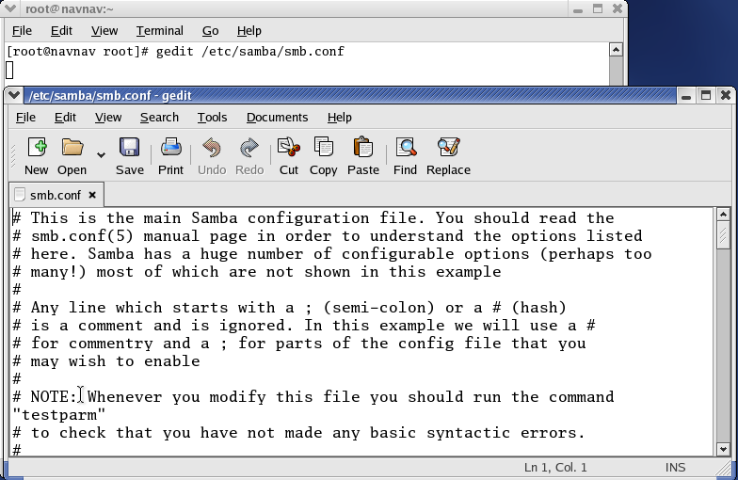
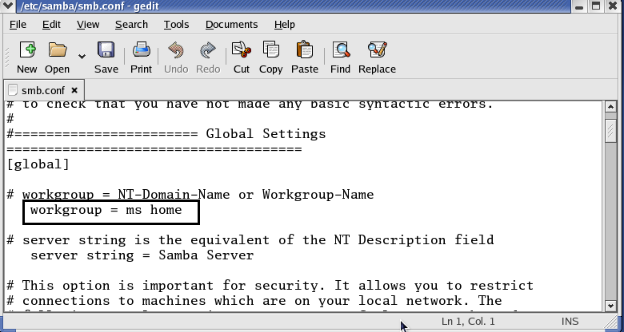

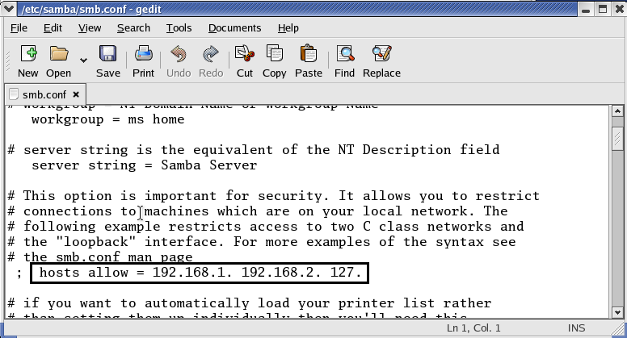

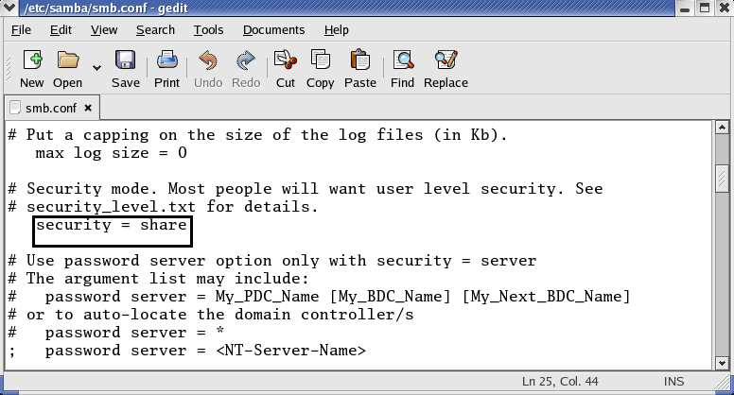

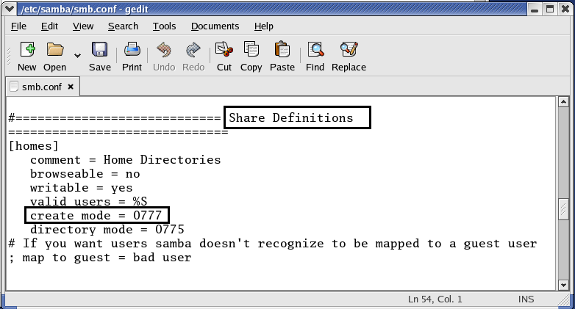
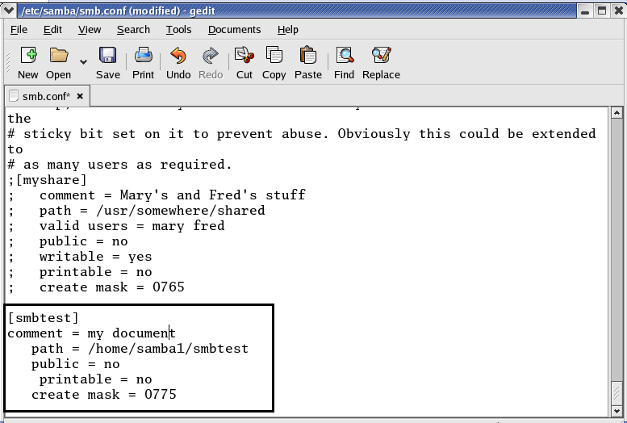

- Start samba service and execute the samba client command to establish connection with the server using server’s IP address and samba user details.
Here you will see that sharable resource type is Disk.
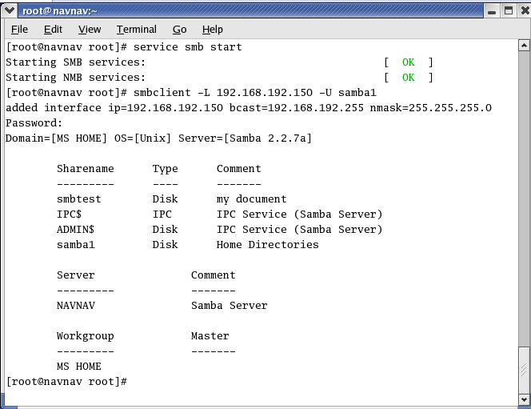

- Again open configuration file and write the value of printable as yes which was earlier mentioned as no
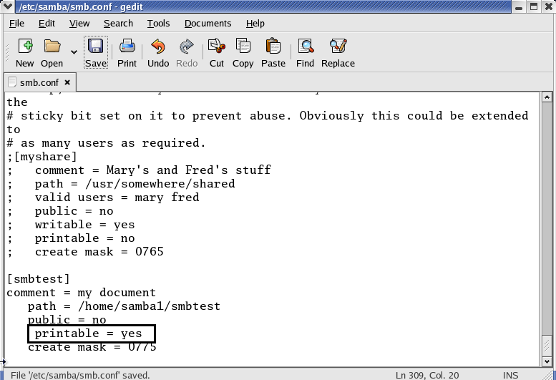

- Start samba service and execute the samba client command to establish connection with the server using server’s IP address and samba user details.
Here you will see that sharable resource type as Printer and disk.

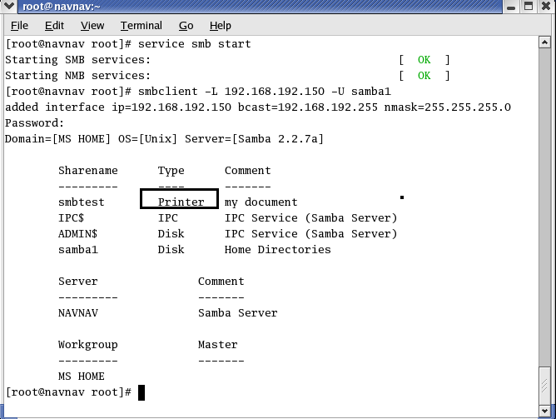

SAMBA – SWAT (Samba Web Admin Tool)
- Follow the process of samba.
- Mount CD3 and install samba-swat package
- Make following changes to samba swat configuration file (xinetd.d/swat). Write IP address of samba server as the value of only_from.
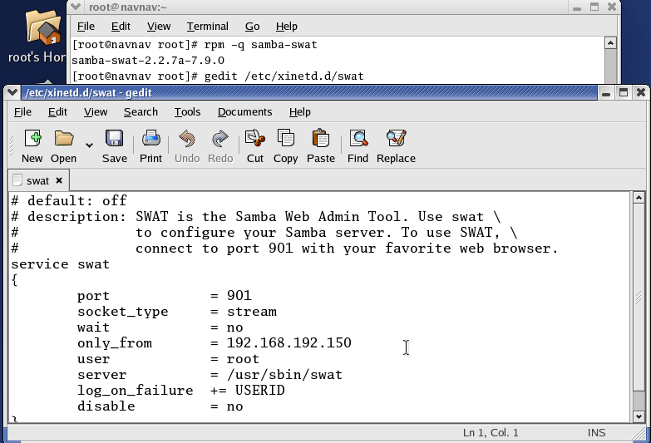

- Start the service of samba (smb) and samba swat (using xinetd) as follows:
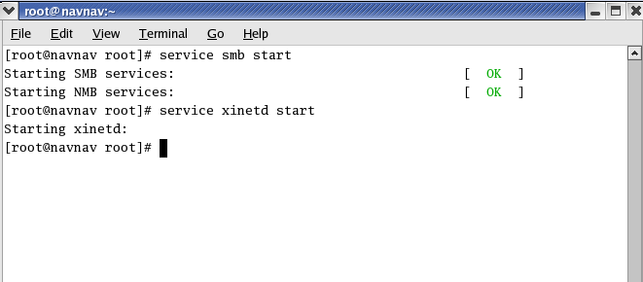
- Open browser and type the URL as
http:// IPADDRESS of samba server : Port number
For Eg: here its http://192.168.192.150:901
And press enter. You will see a prompt box. Enter samba user name and samba password here and click on OK.

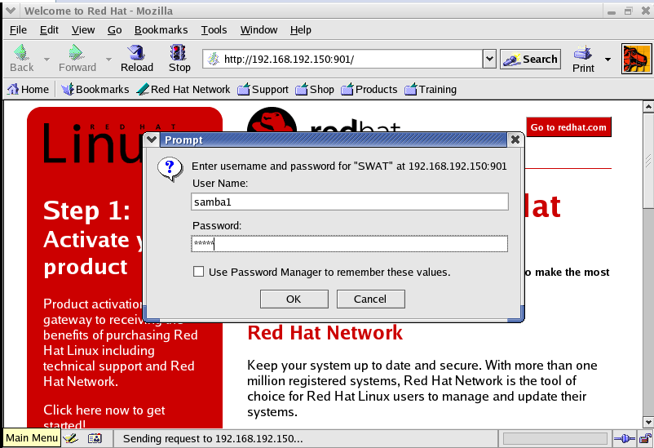

- You will see graphical interface of samba from where resource sharing can be done.
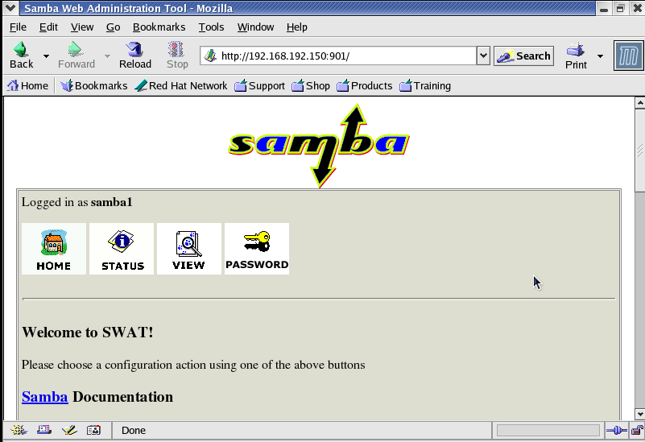

Its all about samba and samba-swat.

